Project Title Wine Chemical Profile Segmentation & Outlier Detection

Algorithms K-Means | Isolation Forest

Objectives:
Group wines by physicochemical profile and detect samples with unusual chemical combinations. Use K-Means for interpretable wine-style segments and Isolation Forest for outlier discovery, then study how quality scores differ across the resulting groups.

Tasks to Complete: Complete

1 Load red and/or white wine data, inspect all chemical features, missing values, duplicates, and quality distribution.

2 Exclude quality during unsupervised training. Keep it only for post-hoc analysis of clusters and anomalies.

3 Perform EDA with histograms, box plots, correlation heatmap, and red-vs-white comparisons when both datasets are used.

4 Scale features and train K-Means for k = 2 to 8. Select k using elbow, silhouette, Davies-Bouldin, and stability.

5 Profile each cluster using acidity, residual sugar, sulphates, alcohol, density, and post-hoc quality distribution.

6 Train Isolation Forest with several contamination settings and analyse anomaly-score thresholds.

7 Inspect anomalous wines and explain which chemical measurements make them unusual.

8 Compare the purpose and output of clustering versus anomaly detection, including overlap between rare clusters and anomalies.

9 Create a visual dashboard and write recommendations for quality-control review without claiming a medical or safety decision.

Report:
1. 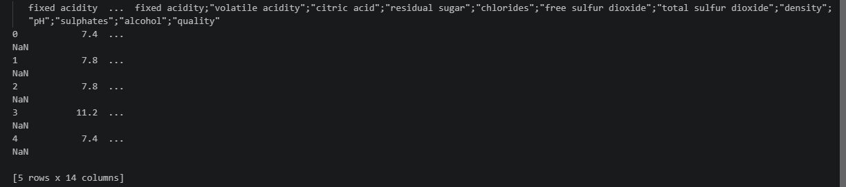

Data was loaded.
